Experiment 5 Quantization

Objective: To understand quantization
To appreciate the effect of quantization

Background information
Signals from the real world are often in the analog form. As you know from the sampling experiment, a real world signal x(t) has to be sampled before it can be processed digitally. But before the sampled signal x(n) is sent to a digital computer or DSP processor, the value of each sample x(n) must be represented by a digital number, mostly in the form of a binary number or code x(n) inside a computer. The process converting x(n) into a binary code sequence x_{q}(n) is called quantization. Once the word-length of the codes has been chosen, the number of codes available for representing x(n) is limited. For example, the number of 3-bit codes is 8, i.e. 000, 001, 010, 011, 100, 101, 110, 111. Each code denotes a quantization level. In this case, the number of quantization levels is 8. Any value of a sample x(n) can only be represented in one of these 8 available levels. In other words, x_{q}(n) can only have 8 different values after quantization . Hence, quantization errors result.

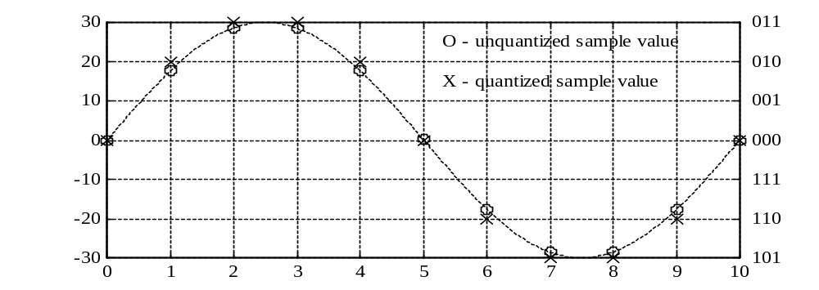
Figure 5–1 – Example of a sampled signal waveform x(n)

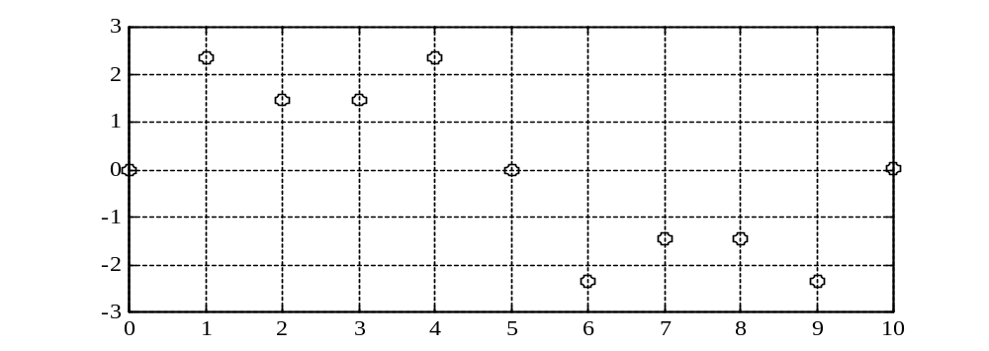
Figure 5–2 – Quantization error e(n)

Figure 5–1 shows a sampled waveform x(n) and the corresponding quantized sample sequence x(n) when the word-length is 3 bits. In this example, the code or level representation is shown in the table below.

Binary Code | 011 | 010 | 001 | 000 | 111 | 110 | 101 | 100
Quantization  Level (volts) | 30 | 20 | 10 | 0 | –10 | –20 | –30 | –40

Hence, the quantization level difference Δ is 10 volts.

The quantization error is
e(n) = x_{q}(n) – x(n) [1]

or
x_{q}(n) = x(n) + e(n) [2]

Figure 5–2 shows the quantization error for the example in Figure 5–1.

The effect of quantization can be considered as adding an error signal e(n) onto the actual sampled signal x(n) in the time domain. Generally, e(n) is considered as an independent random noise and its spectrum spreads across the whole frequency range. Obviously, the smaller the amplitude of the error signal e(n) , the less is the effect of quantization on the signal processing procedure.

Procedure 1: Quantization of a ramp signal

- A MATLAB routine had been provided which can be used to quantize a signal. View the description of the routine:

>>help quant

- We will now quantize a ramp signal using a 3-bit code word.

>>x=[-1:0.02:1];
>>x_q=quant(x,3);

To view the signals:

>>subplot(1,2,1),lineplot(x);
>>subplot(1,2,2),lineplot(x_q);

What did you observe?
The quantized signal resembles a staircase. This is because the amplitude of the signal is forced to take on only 8 discrete values.
_____________________________________________________________________

- Notice that the encoded signals have values ranging from -3 to 3. These are actually the decimal (base-10) versions of the binary (or hexadecimal) codewords. A MATLAB routine had been provided to convert them into hexadecimal. View the description of the routine:

>>help num2hex

This function converts an integer x to a n-bit hex number
View the first 10 samples of x_q in hexadecimal form:

>>num2hex(x_q(1:10),3)

What did you observe? Can you account for the result?

A value of 5 is observed. This is actually a 3-bit binary code, 101. As it is a signed number, its decimal equivalent is -3.

_____________________________________________________________________

- By zooming into the plots, identify the range of analog values of x that are being encoded to a value of −3. Repeat the process for all the other encoded values:

Encoded value | Analog value range
−3 | −1 to −0.84
−2 | −0.82 to −0.5
−1 | −0.48 to −0.18
0 | −0.16 to 0.16
1 | 0.18 to 0.48
2 | 0.5 to 0.82
3 | 0.84 to 1
Table 5–1

Alternatively, you can use the following statement to compare the values:

>>[x;x_q]'

- From Table 5–1, can you estimate the quantization step size?
_____________________________________________________________________

- In general, the quantization noise is always less than half of the quantization step size. To determine the quantization noise, we need to convert the codewords back to analog values and then find the difference between the quantized and the original values. A MATLAB routine had been provided to determine the maximum quantization noise:

>>help quant_noise;

To find the maximum quantization noise generated by the 3-bit encoding:

>>quant_noise(x,x_q,3);

What is the maximum quantization noise? Is the value close to half of the quantization step size?
_____________________________________________________________________

- Repeat steps 1-2 to 1-6 for a 4-bit code word.

>> x_q=quant(x,4);
>> subplot(1,2,1),lineplot(x);
>> subplot(1,2,2),lineplot(x_q);

What are the maximum and minimum encoded values?

What is the estimated quantization step size?

>> quant_noise(x,x_q,4)

_____________________________________________________________________

- Repeat step 1-2 for a 8-bit code word.

Did you see any steps (as in the 3-bit case) in the encoded signal? Do you think the encoded signal is a good representation of the original signal?

_____________________________________________________________________

Can you estimate the quantization step size?

_____________________________________________________________________

What is the maximum quantization noise?

_____________________________________________________________________

Can you deduce a relationship between the maximum quantization noise and the quantization word length?

_____________________________________________________________________

Without actually computing it, can you estimate the maximum quantization noise of a 10-bit encoded signal?

